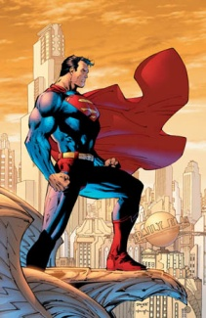
Classroom Heroes
Sneak a Peek Behind the Mask!

It is my belief that the more invested you become in this class (and in life), the more successful you will be. Furthermore, I believe that this class (and life) becomes so much more rewarding when you establish personal connections, and when you become invested in your fellow classmates. So often, we go through our days without ever truly seeing other people—the faces behind the masks. This fun activity allows you to express yourself…your interests, beliefs, hobbies and strengths, and to sneak a peek behind the “masks” of fellow classmates, helping us to truly know, understand, and appreciate the heroes all around you—the heroes that lie within.
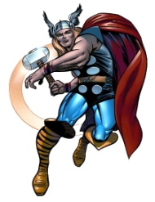
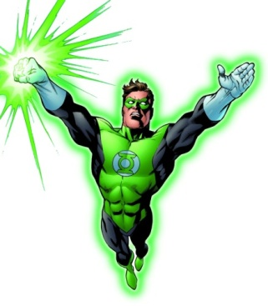
Pictures, drawings, magazine cuttings, personal objects, scraps, etc. are all welcome (and encouraged) for this project. Think outside the box! Remember, this is a reflection of you! Explore your passions, and let your creativity shine as you assemble the artifacts that truly reflect the hero within you. Hopefully, as you complete this activity, you will allow yourself to be creative, and to establish a stronger connection to this class. I think you will enjoy seeing personalities emerge as other classmates take off their masks to reveal their alter egos! Be sure to include these artifacts:
Name
Superhero Name
Picture of Yourself
Origins: Pictures of family, Birthplace, Where you came from.
Alter Ego: Hobbies, Interests, Things we don’t know about you. Can include favorite music, movies, sports, etc.
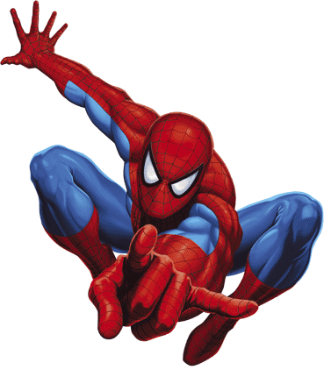
Personality: Use adjectives to describe yourself.
Allies: Can include friends, mentors, etc.
Arch Enemy: A problem that plagues you, something you strongly dislike. Ie: Laziness
Headquarters: Describe your sanctuary.
Theme/Motif: Describe your inspiration. Ie: Batman was inspired by Bats.
Extraordinary Powers and Abilities
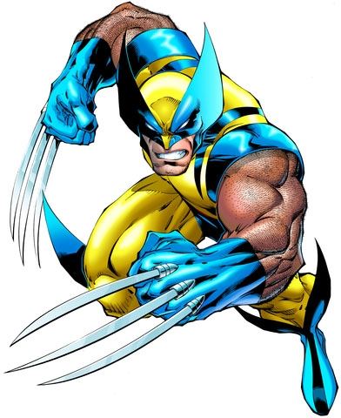
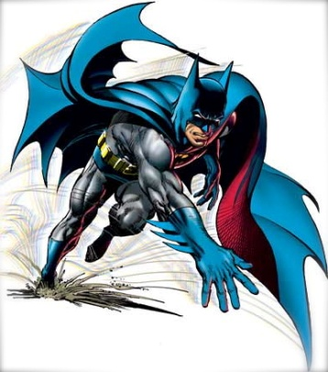
Motivation: Belief in Justice, Belief in Family
Costume Design
Strengths
Weakness (Something to Improve)
Quote:

